1. Complete the table given below

|  |  |  |  |  |
| --- | --- | --- | --- | --- |
| IP ADDRESS | CLASS NAME | DEFAULT SUBNET MASK | NETWORK  ADDRESS | HOST ADDRESS |
| 10.101.1.0 | B | 255.255.0.0 | 10.101.0.0 | 0.0.1.0 |
| 151.110.102.103 | A | 255.0.0.0 | 151.0.0.0 | 0.110.102.103 |
| 109.1.0.1 | A | 255.0.0.0 | 109.0.0.0 | 0.1.0.1 |
| 1.0.0.5 | A | 255.0.0.0 | 1.0.0.0 | 0.0.0.5 |
| 190.10.48.50 | C | 255.255.255.0 | 190.10.48.0 | 0.0.0.50 |
| 123.169.23.20 | B | 255.255.0.0 | 123.169.0.0 | 0.0.23.20 |
| 70.10.18.50 | C | 255.255.255.0 | 70. 10.18.0 | 0.0.0.50 |
| 186.13.1.110 | B | 255.255.0.0 | 186.13.0.0 | 0.0.1.110 |

|  |  |  |  |  |
| --- | --- | --- | --- | --- |
| IP ADDRESS | CLASS NAME | DEFAULT SUBNET  MASK | NETWORK  ADDRESS | HOST ADDRESS |
| 101.191.91.131 | A | 255.0.0.0 | 101. 0.0.0 | 0.0.0.131 |
| 10.101.0.0 | A | 255.0.0.0 | 10.0.0.0 | 0.101.0.0 |
| 12.10.16.0 | B | 255.255.0.0 | 12.10.0.0 | 0.0.16.0 |
| 107.0.0.5 | C | 255.255.255.0 | 107.0.0.0 | 0.0.0.5 |
| 1.0.8.50 | C | 255.255.255.0 | 1.0.8.0 | 0.0.0.50 |
| 105.109.203.200 | B | 255.255.0.0 | 105.109.0.0 | 0.0.203.200 |
| 170.190.78.50 | C | 255.255.255.0 | 170.190.78.0 | 0.0.0.50 |
| 106.13. 0.110 | B | 255.255.0.0 | 106.13.0.0 | 0.0.0.110 |

1. Convert the first Octet of your IP Address into decimal and identity the class of the ip address. 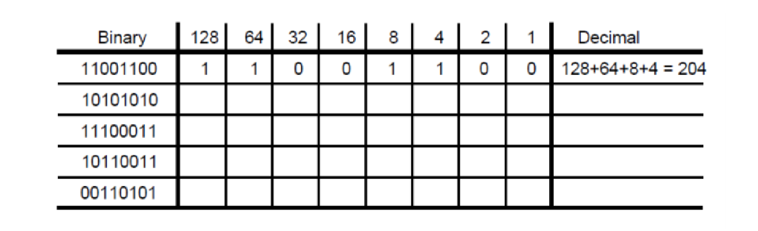

|  |  |  |  |  |  |  |  |  |  |
| --- | --- | --- | --- | --- | --- | --- | --- | --- | --- |
| Binary | 128 | 64 | 32 | 16 | 8 | 4 | 2 | 1 | Decimal |
| 10101010 | 1 | 0 | 1 | 0 | 1 | 0 | 1 | 0 | 128+32+8+2=170 |
| 11100011 | 1 | 1 | 1 | 0 | 0 | 0 | 1 | 1 | 227 |
| 10110011 | 1 | 0 | 1 | 1 | 0 | 0 | 1 | 1 | 179 |
| 00110101 | 0 | 0 | 1 | 1 | 0 | 1 | 0 | 1 | 53 |
|  |  |  |  |  |  |  |  |  |  |

1. Express 145.32.59.24 in binary format and identify the address class.

* 10010001. 00100000. 00111011. 00011000
* Class B

1. Express 200.42.129.16 in binary format and identify the address class

* 11001000. 00101010. 10000001. 00010000
* Class C

1. Express 14.82.19.54 in binary format and identify the address class

* 00001110. 01010010. 00010011.00110110
* Class A